501 there can be only one start and one end which are ovalsrectangles are stsments and diamonds are decisones
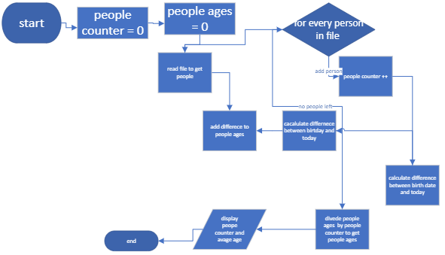

502 this is a flow chart i made


503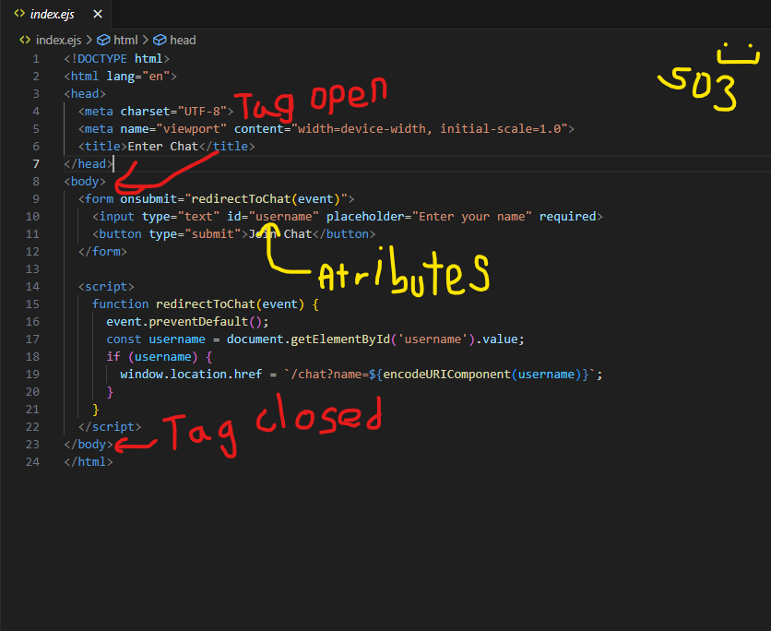

504
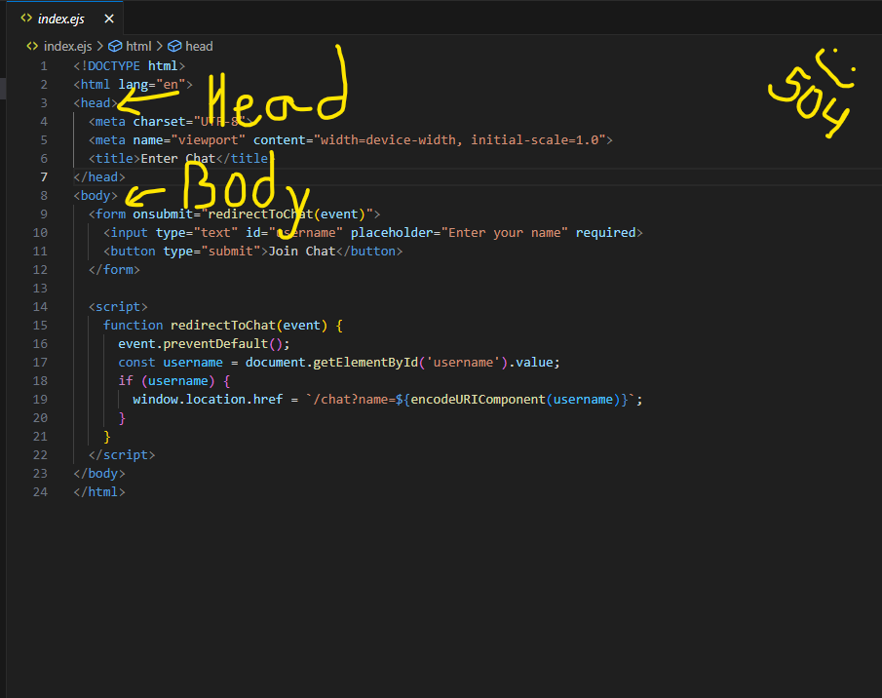
505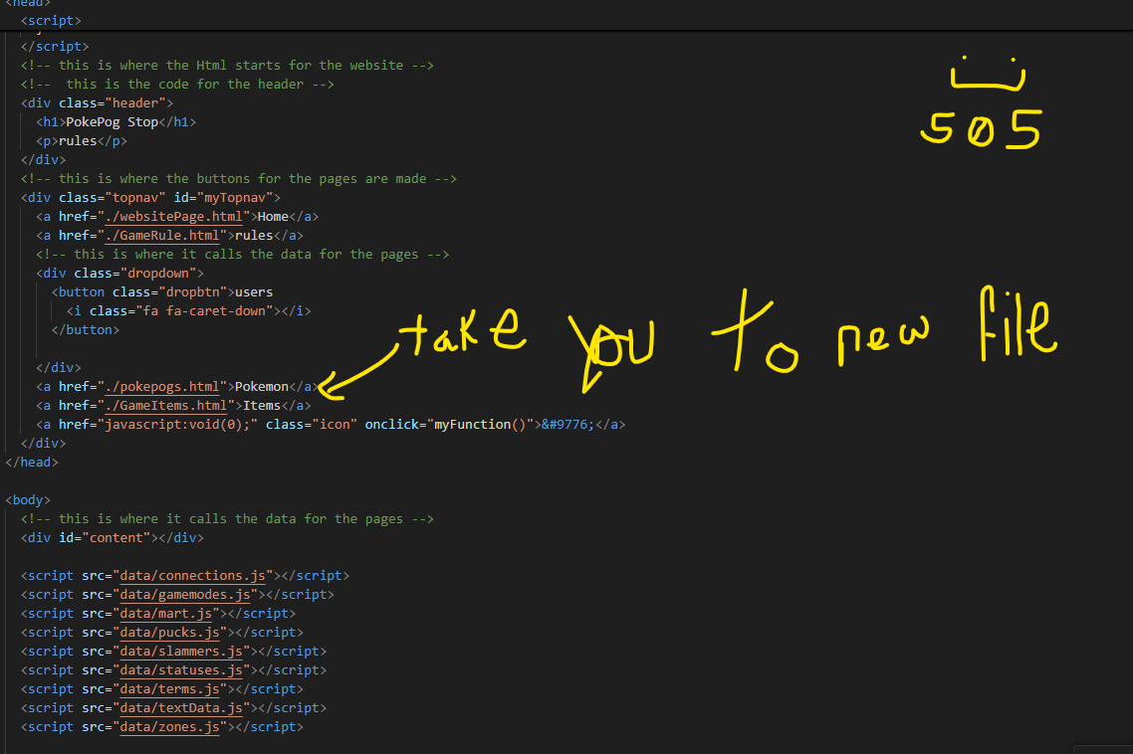

506
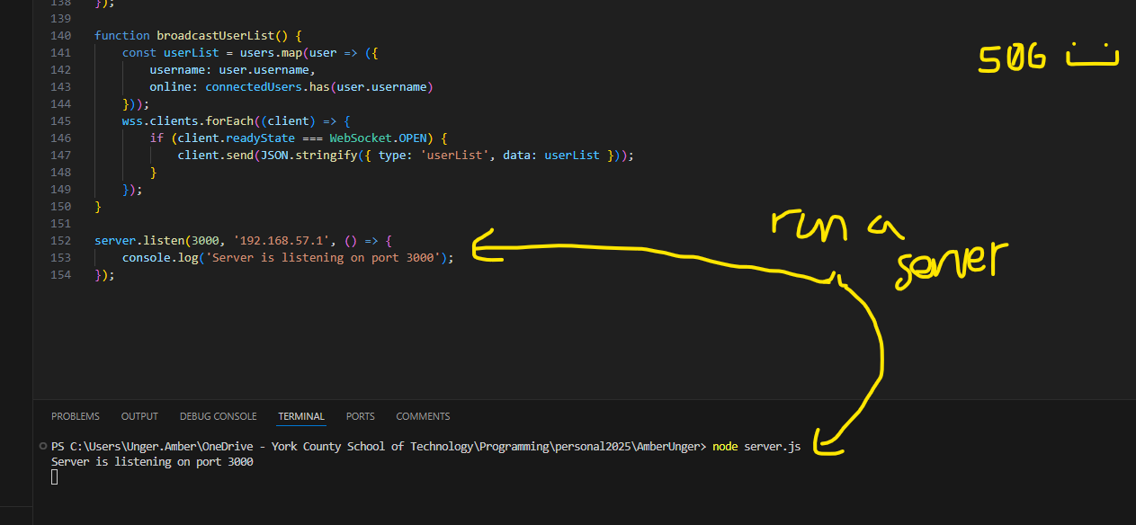
507
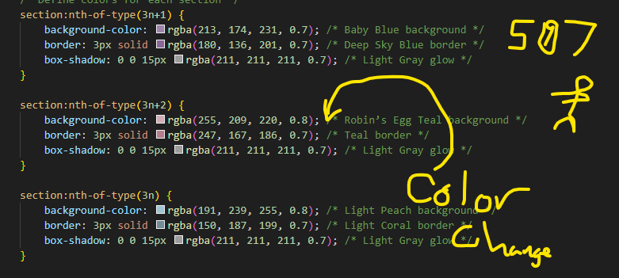
508
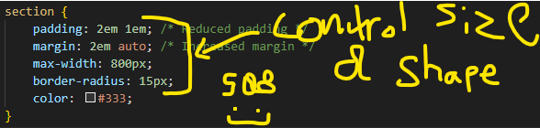
509
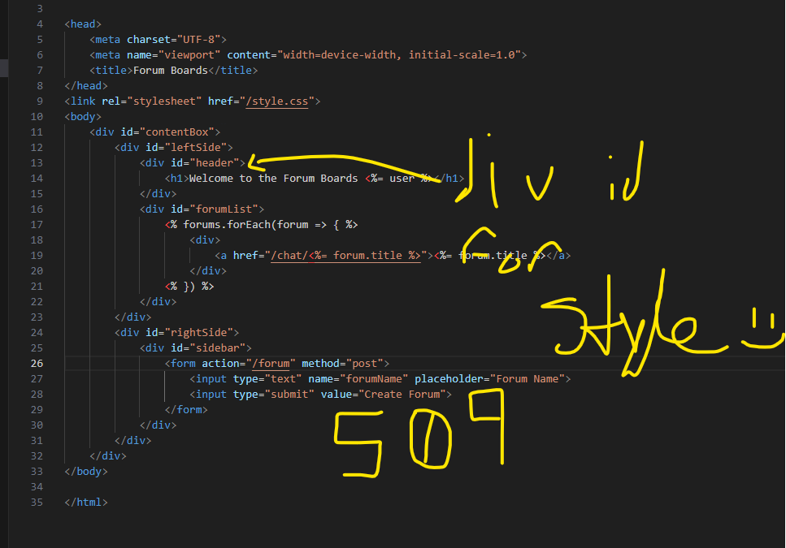
510
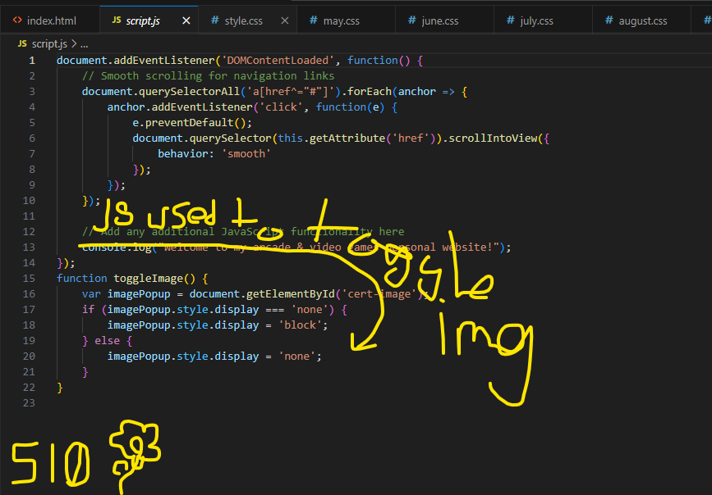
511
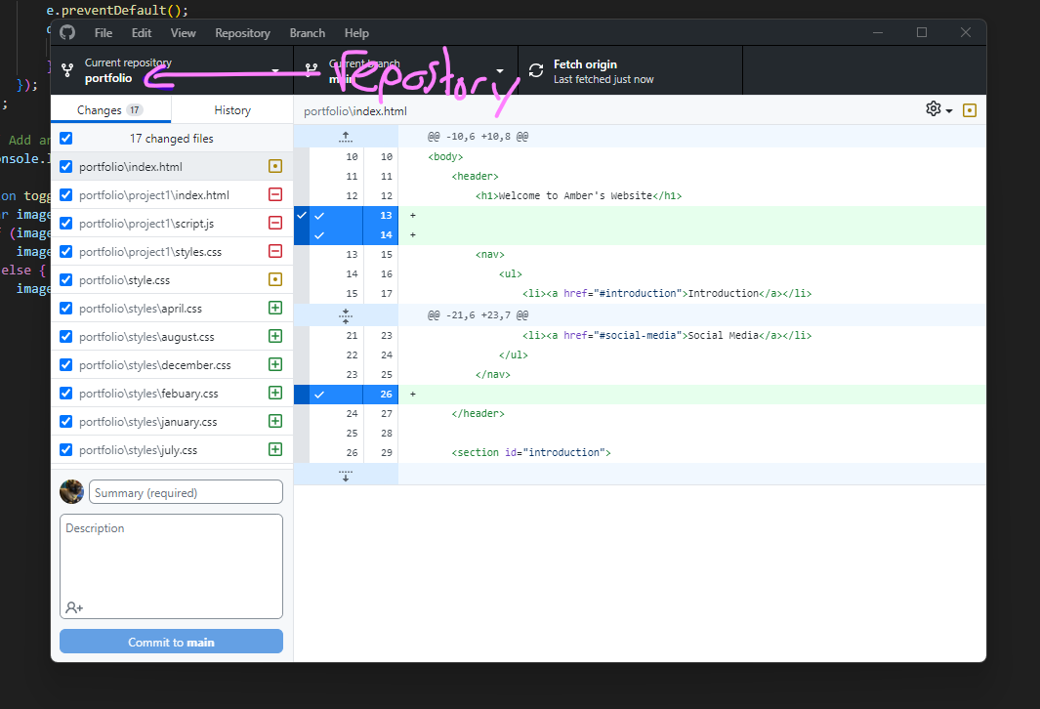
512
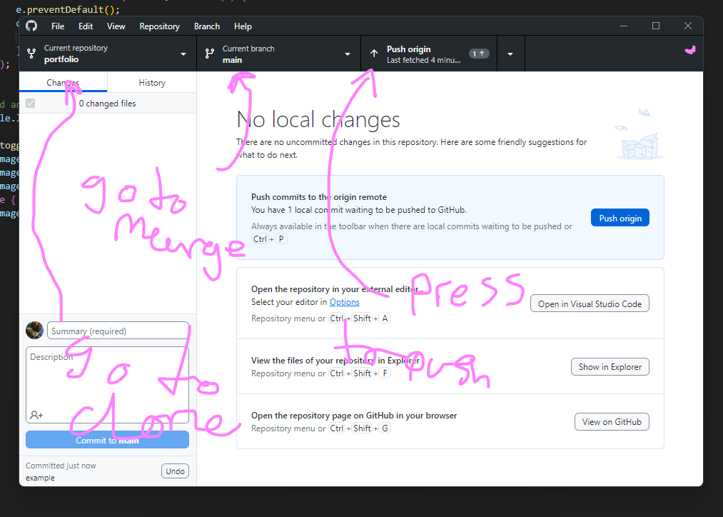
513
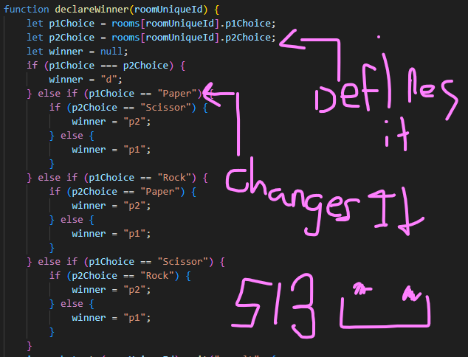

514
If this happens do that
Else if do this
Any thing else do that
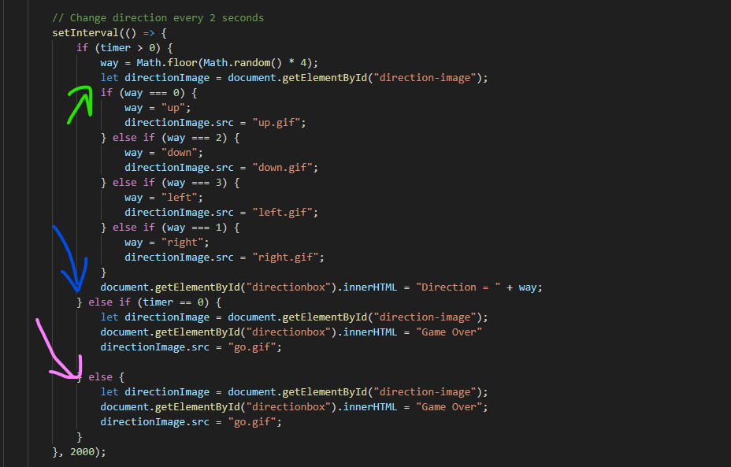
515
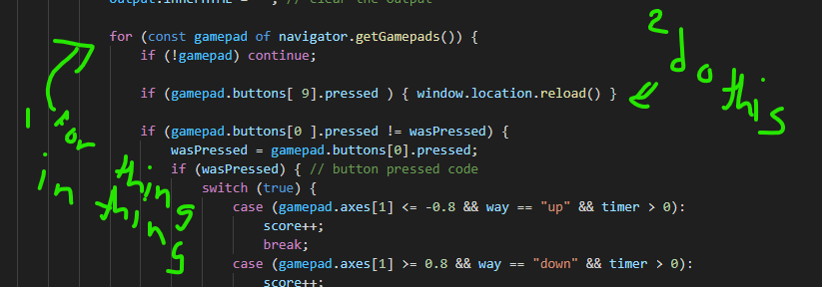
601
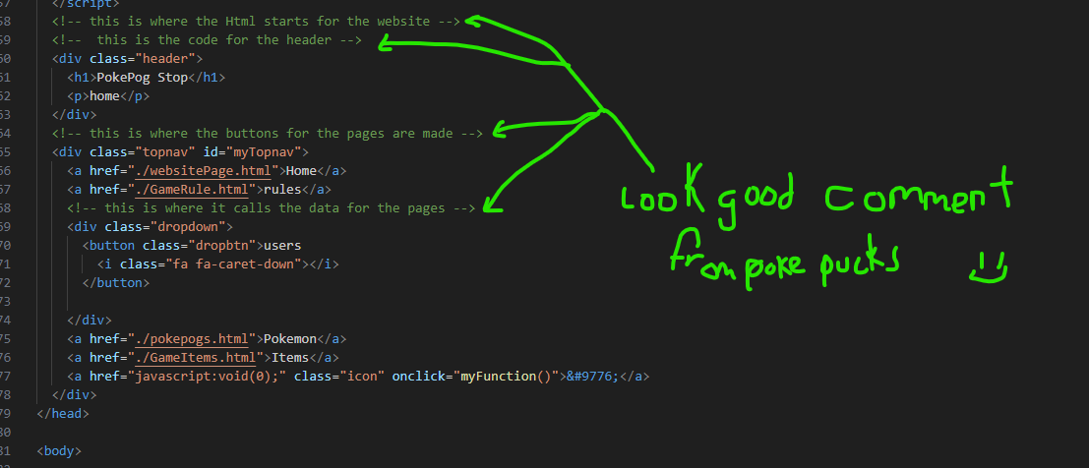

602

A boolean X = true or X = false
A integer X =1 ( or any other whole number)
A float x= -12 or x = 3.14159 (any number thats not a whole number)
And a string x = “hi” “no crotaines means its = to a variable like ( x = y ))

603

X = “hi”
Answers = User input = “25th of june”
Assigning the user input to the variable answers to save it

604
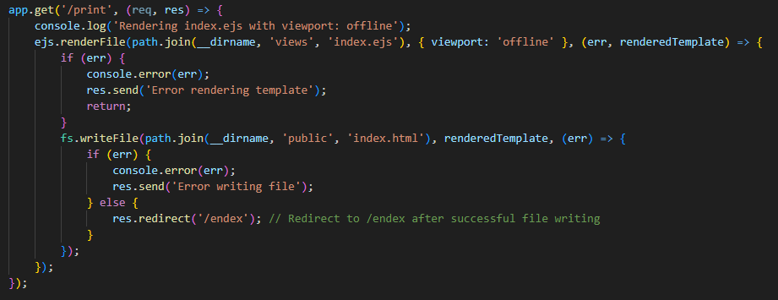

605
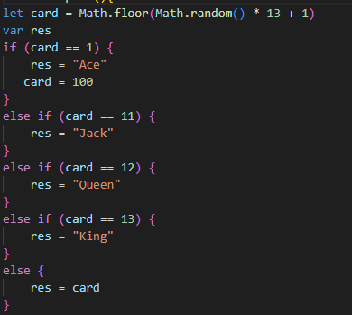
606

A for loops does something for each of something for example

For each question in test console.log (answers)

Unlike a while loop that does something when a condition is set for example

While day = true console.log (“you can only sleep at night”)

607
When this AND this is true do that
Then this OR this is true do that
When this is NOT true do that
608
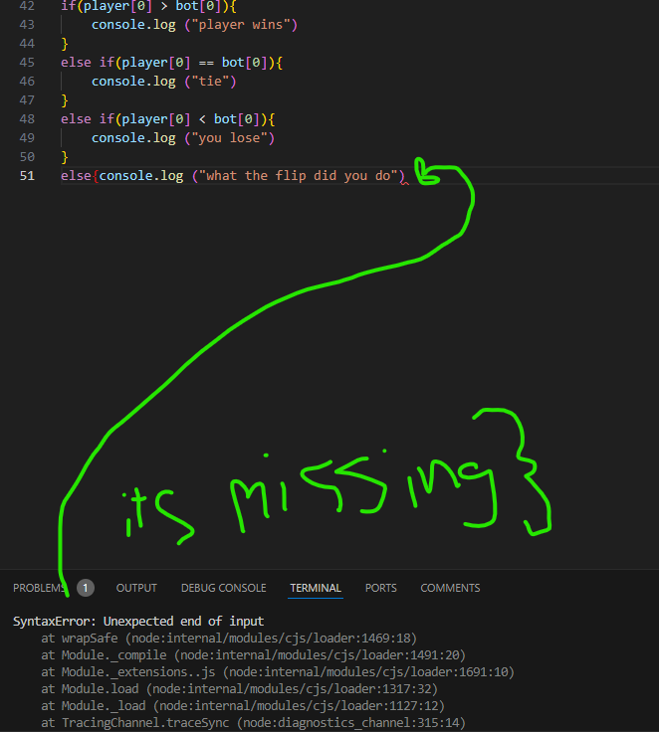
609
Opps i forgot this to late now (;
610

611
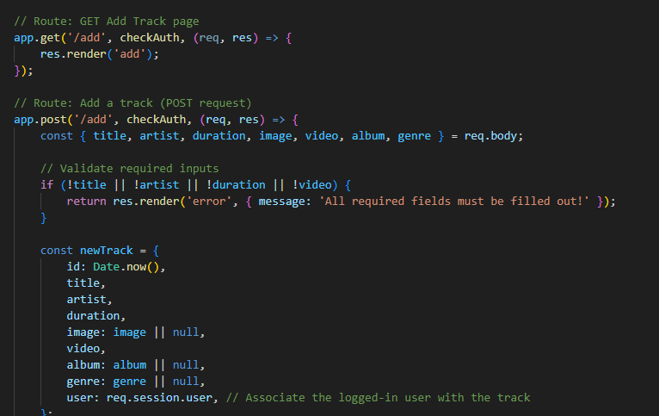
612

613

614

615

